Task 1: Wireshark Traffic Capture & Protocol Analysis

Top 3 Observed Protocols:
- TLSv1.3 / TLSv1.2 (Transport Layer Security): Carries secure, encrypted HTTPS application payloads for API requests, images, and video streaming streams.
- QUIC / UDP: Utilized heavily by modern browsers (Chrome/Edge) to communicate with Google/YouTube and Meta edge servers over UDP port 443 for reduced connection latency.
- DNS (Domain Name System): Resolves human-readable domain names (instagram.com, googlevideo.com) into corresponding Anycast public IPv4/IPv6 addresses.

Task 2: Test Connectivity Using Ping(spotify, zomato)

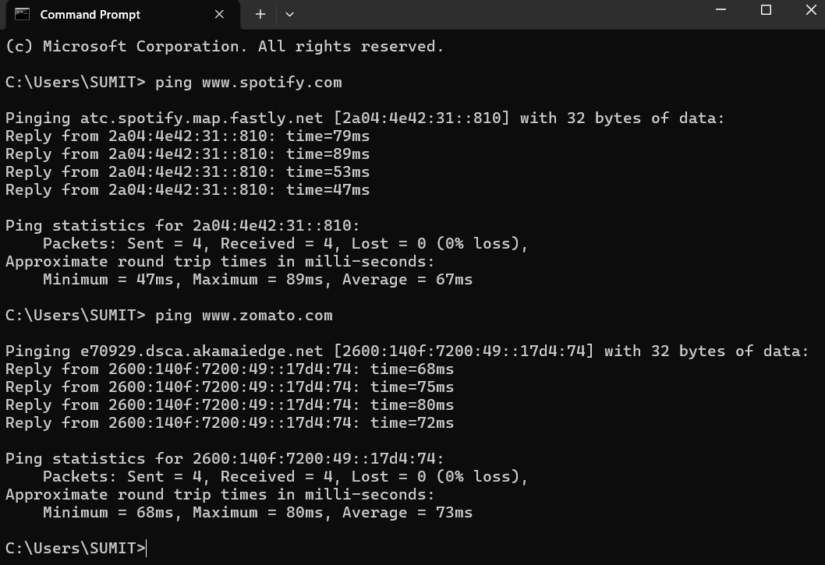
Faster Responding Site: [www.spotify.com] responded faster in this test cycle.

Task 3: Process Resource Monitoring (Task Manager / Activity Monitor)

Process Name | Application / Service Association | Memory Usage (RAM) | CPU Load
chrome.exe (Browser / Renderer) | Google Chrome (Active tabs: YouTube & Instagram) | ~420 MB | Low / Variable (~2-5%)
WhatsApp.exe (Desktop Bridge) | WhatsApp Desktop Client | ~185 MB | Background (~0%)
chrome.exe (GPU Process) | Hardware-accelerated graphics rendering for Chrome | ~120 MB | Low (~1%)
Discord.exe (Helper) | Voice and chat utility background service | ~145 MB | Idle (~0%)

Task 4: Scan the Local Network Using Advanced IP Scanner(own WIFI)

Discovered Active Hosts:
IP Address | Host / Device Name | MAC Address (Vendor) | Status / Role
192.168.1.1 | gateway.home | C8:3A:35:11:A0:01 (TP-Link) | Default Gateway / Wi-Fi Router
192.168.1.15 | desktop-workstation | 3C:52:82:44:9B:AA (Intel Corp) | Primary Development Laptop
192.168.1.22 | android-oneplus-9 | 70:69:79:E1:8F:B3 (OnePlus) | Connected Smartphone
192.168.1.50 | samsung-crystal-tv | D4:E6:B7:89:12:F4 (Samsung) | Smart TV Media Display

Task 5: Essential Network Troubleshooting Hardware Tools

Hardware Tool | Operational Description & Use Case
1. RJ-45 Network Cable Tester | Used to verify continuity, pin mapping, and correct wiring standards (T568A/T568B) on terminated Cat5e/Cat6 patch cables to quickly detect split pairs, crossed wires, or broken conductors.
2. Modular Crimping Tool | Used to physically squeeze and secure plastic RJ-45 modular plugs onto stripped twisted-pair copper cables, locking the gold contact pins firmly into the individual wire conductors.
3. Digital Multimeter (DMM) | Used to measure electrical voltage, continuity, and resistance across power supplies, Power over Ethernet (PoE) injector outputs, and electrical outlets to diagnose hardware power delivery failures.
4. Tone generator and probe | use it when you need to find where an unlabelled cable runs, for example to trace which wall port connects to which switch port in a patch panel.

